**JAVA PROGRAMS**

**DAY 1**

**PROGRAM 1: Day1_Simple.java**

**package** com.ust.test;

**public** **class** Day1_Simple {

**public** **static** **void** main(String[] args){

**int** a=10;

**float** f=a;

System.***out***.println(a);

System.***out***.println(f);

}

}

**OUTPUT**

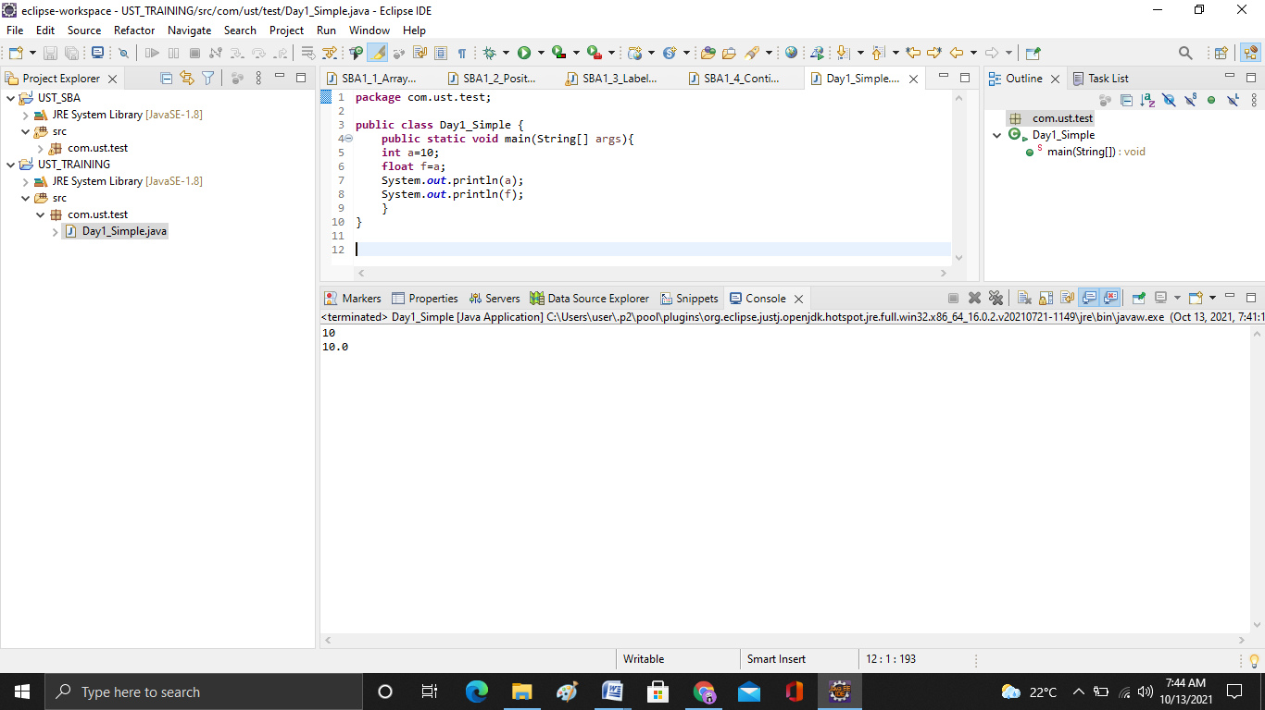

**PROGRAM 2: Day1_TypeCast**

**package** com.ust.test;

**public** **class** Day1_TypeCast {

**public** **static** **void** main(String[] args){

**byte** a=10;

**byte** b=10;

**byte** c=(**byte**)(a+b);

System.***out***.println(c);

}

}

**OUTPUT**

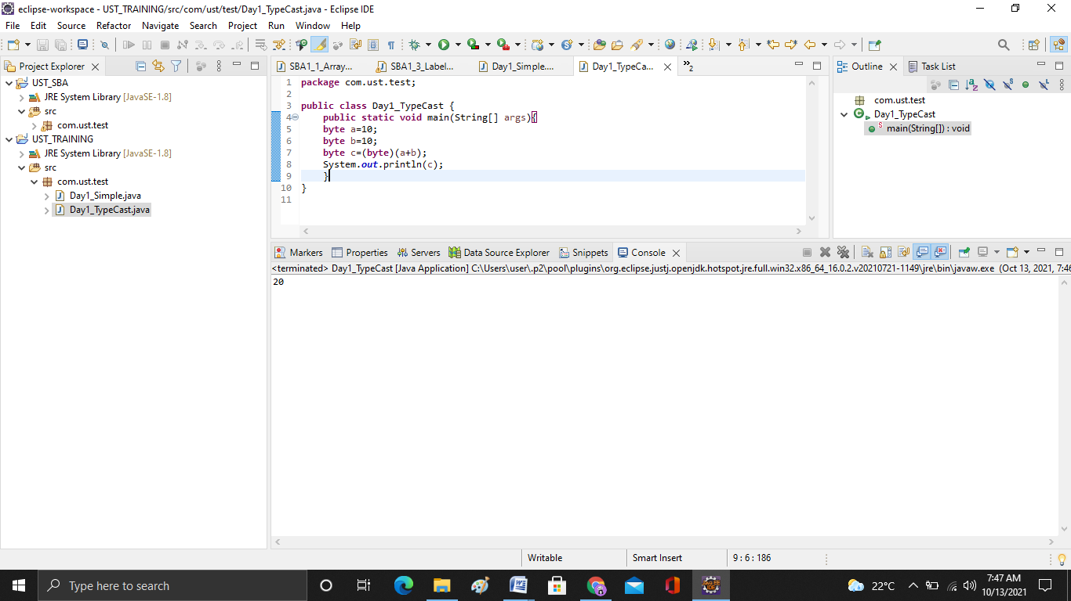

**PROGRAM : Day1_IfExample.java**

**package** com.ust.test;

**public** **class** Day1_IfExample {

**public** **static** **void** main(String[] args) {

**int** age=20;

**if**(age>18){

System.***out***.print("Age is greater than 18");

}

}

}

**OUTPUT**

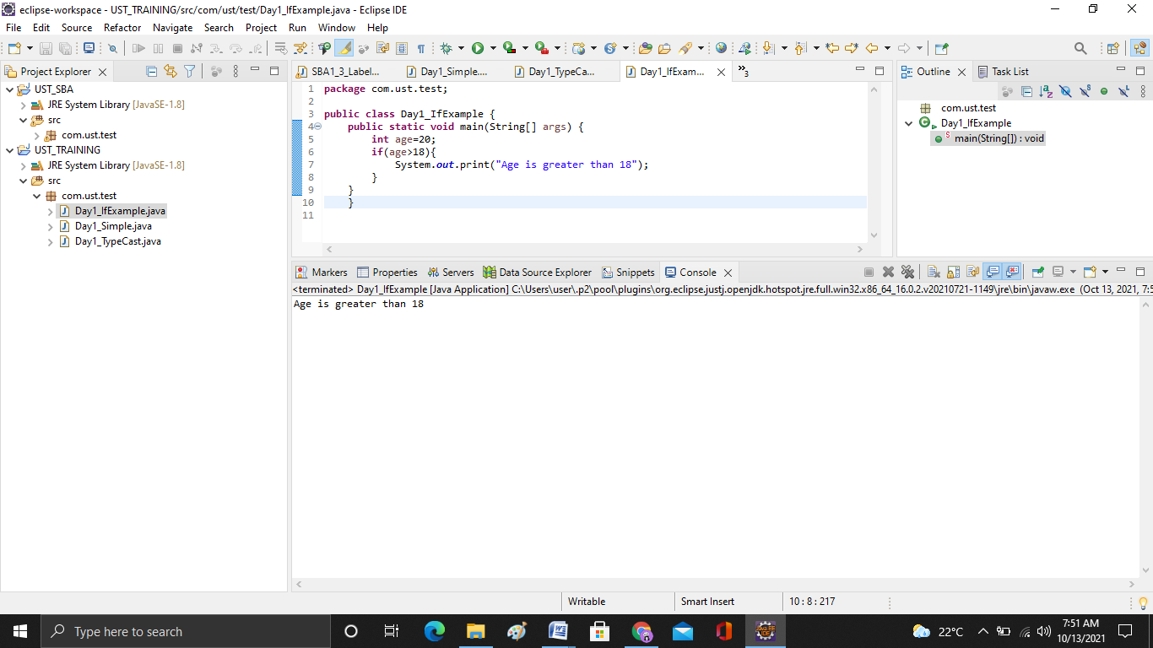

**PROGRAM : Day1_IfElseExample.java**

**package** com.ust.test;

**public** **class** Day1_IfElseExample {

**public** **static** **void** main(String[] args) {

**int** number=13;

**if**(number%2==0){

System.***out***.println("even number");

}**else**{

System.***out***.println("odd number");

}

}

}

**OUTPUT**

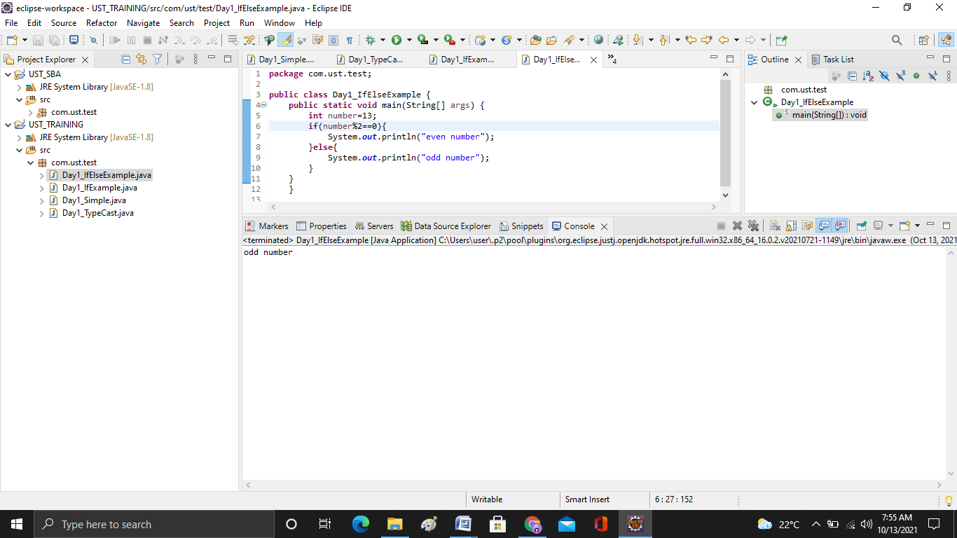

**PROGRAM : Day2_ForEachLoop.java**

**package** com.ust.test;

**public** **class** Day2_ForEachLoop {

**public** **static** **void** main(String[] args) {

**int**[] numbers = {3, 9, 5, -5};

**for** (**int** number: numbers) {

System.***out***.println(number);

}

}

}

**OUTPUT**

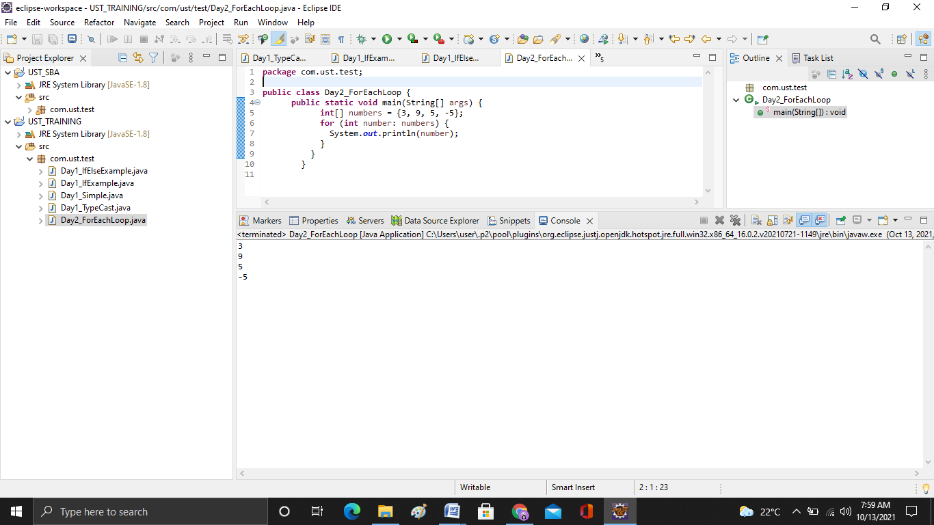

**PROGRAM : Day2_** **SumOfPosiitiveNos.java**

**package** com.ust.test;

**import** java.util.Scanner;

**public** **class** Day2_SumOfPosiitiveNos {

**public** **static** **void** main(String[] args) {

**int** sum = 0;

// create an object of Scanner class

Scanner input = **new** Scanner(System.***in***);

// take integer input from the user

System.***out***.println("Enter a number");

**int** number = input.nextInt();

// while loop continues

// until entered number is positive

**while** (number >= 0) {

// add only positive numbers

sum += number;

System.***out***.println("Enter a number");

number = input.nextInt();

}

System.***out***.println("Sum = " + sum);

input.close();

}

}

**OUTPUT**

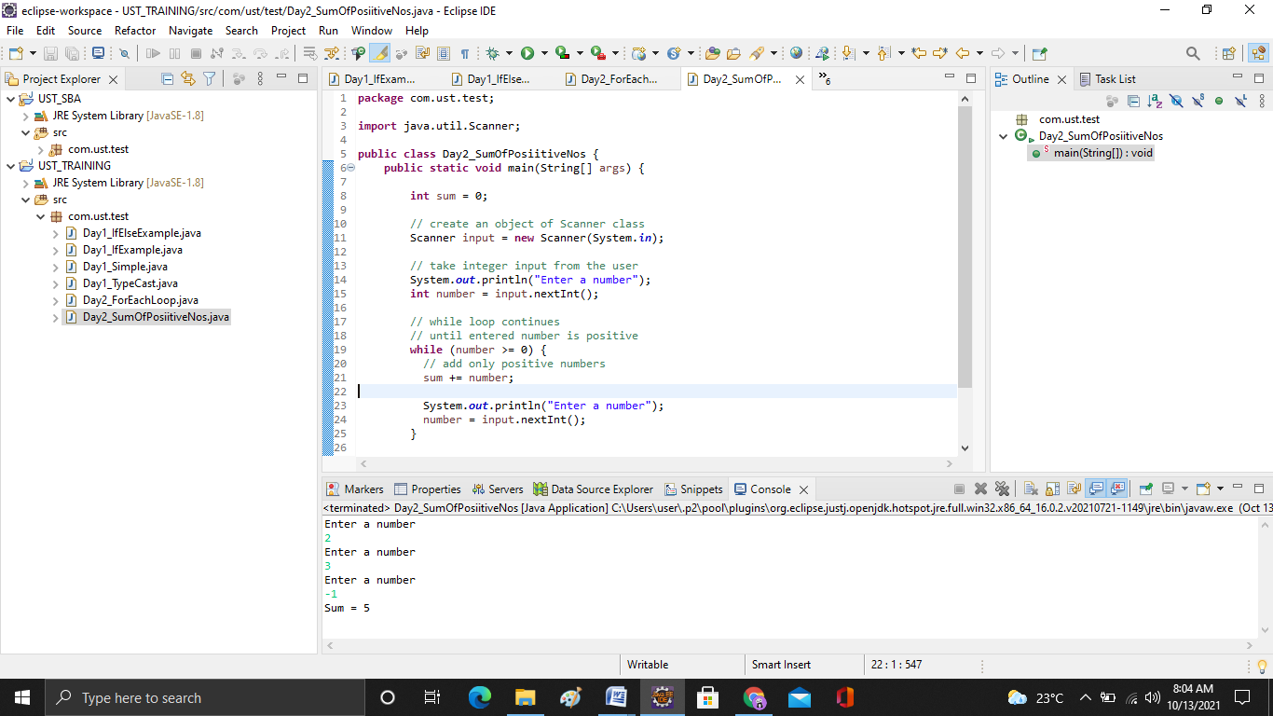

**PROGRAM : Day2_DoWhileLoop.java**

**package** com.ust.test;

**import** java.util.Scanner;

**public** **class** Day2_DoWhileLoop {

**public** **static** **void** main(String[] args) {

**int** sum = 0;

**int** number = 0;

Scanner input = **new** Scanner(System.***in***);

**do** {

sum += number;

System.***out***.println("Enter a number");

number = input.nextInt();

} **while**(number >= 0);

System.***out***.println("Sum = " + sum);

input.close();

}

}

**OUTPUT**

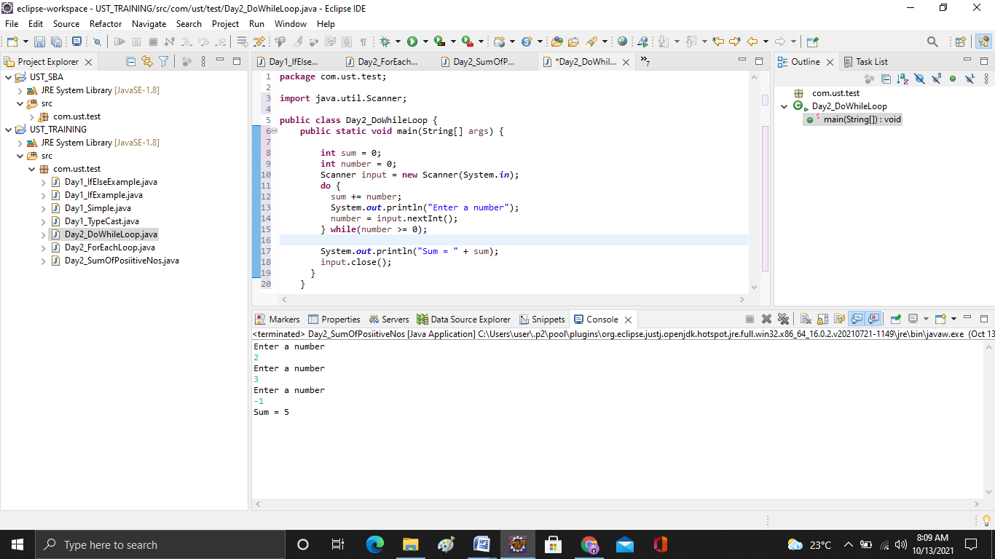

**PROGRAM : Day2_LabelledBreak.java**

**package** com.ust.test;

**public** **class** Day2_LabelledBreak {

**public** **static** **void** main(String[] args) {

first:

**for**( **int** i = 1; i < 5; i++) {

second:

**for**(**int** j = 1; j < 3; j ++ ) {

System.***out***.println("i = " + i + "; j = " +j);

**if** ( i == 2)

**break** first;

}

}

}

}

**OUTPUT**

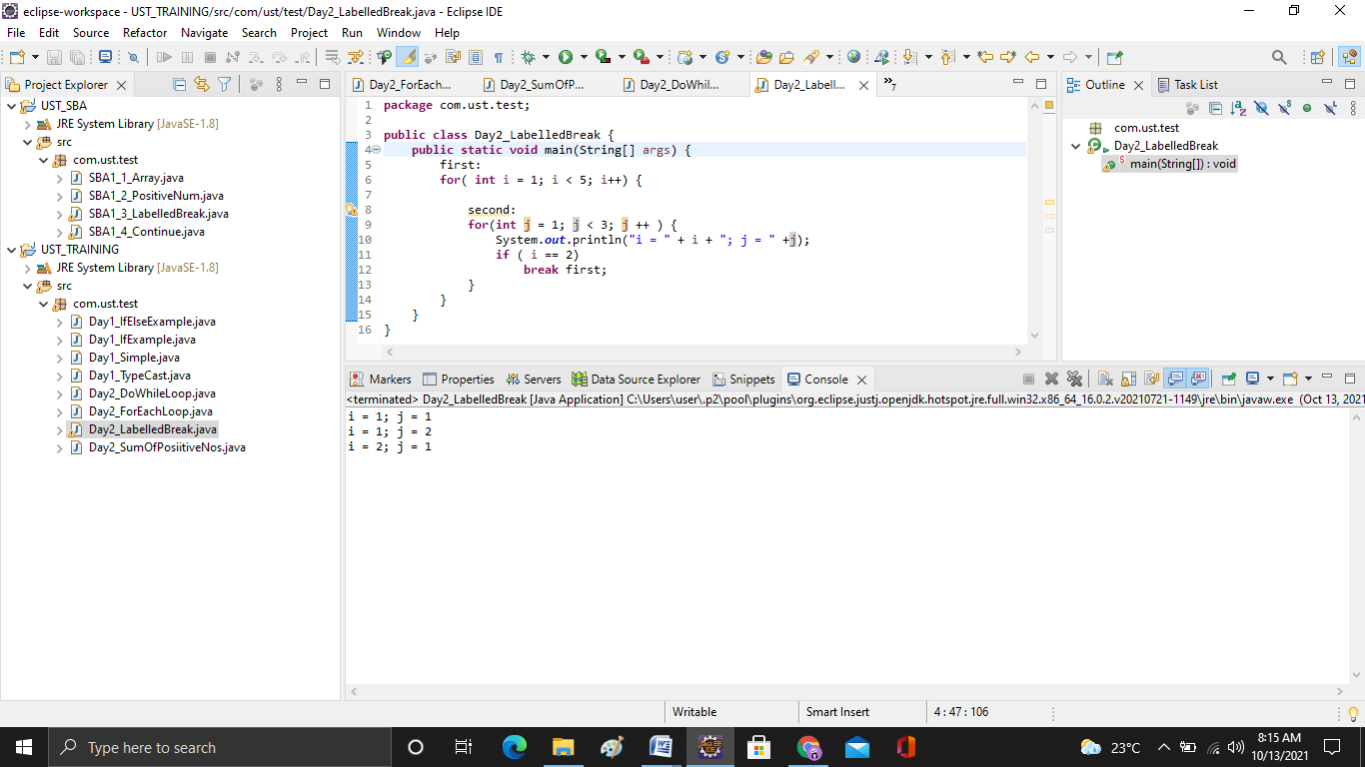

**PROGRAM: Day2_Continue.java**

**package** com.ust.test;

**public** **class** Day2_Continue {

**public** **static** **void** main(String[] args) {

**for** (**int** i = 1; i <= 10; ++i) {

**if** (i > 4 && i < 9) {

**continue**;

}

System.***out***.println(i);

}

}

}

**OUTPUT**

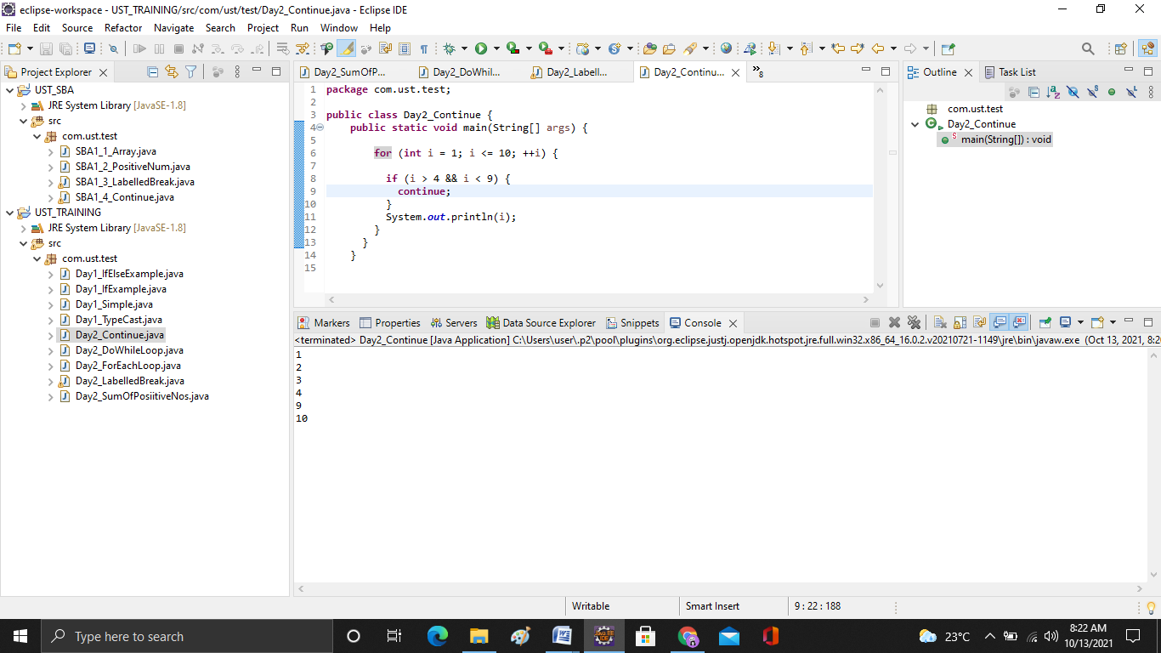

**PROGRAM : Day2_LabelledContinue,java**

**package** com.ust.test;

**public** **class** Day2_LabelledContinue {

**public** **static** **void** main(String[] args) {

first:

**for** (**int** i = 1; i < 6; ++i) {

**for** (**int** j = 1; j < 5; ++j) {

**if** (i == 3 || j == 2)

**continue** first;

System.***out***.println("i = " + i + "; j = " + j);

}

}

}

}

**OUTPUT**

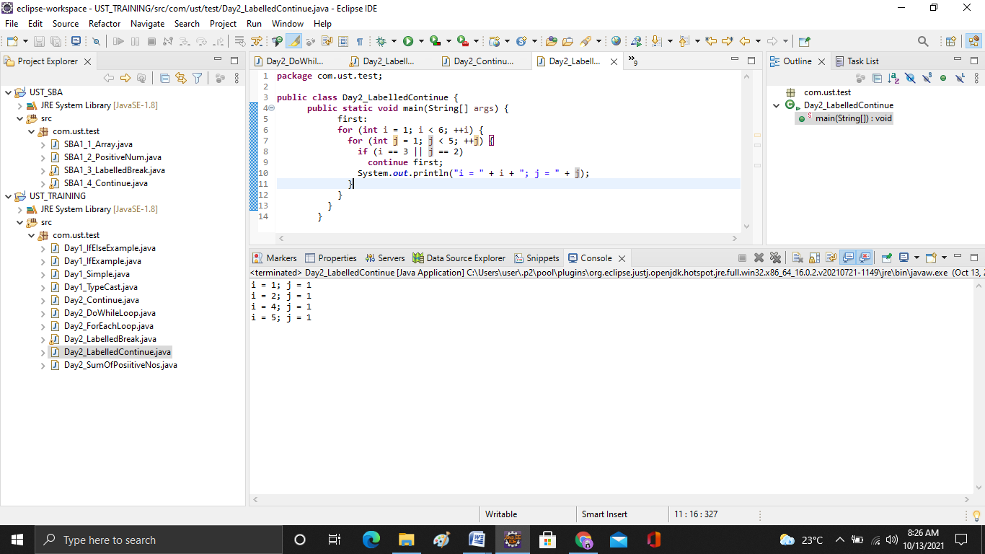

**PROGRAM :** Day2_Array_ForLoop.java

**package** com.ust.test;

**public** **class** Day2_Array_ForLoop {

**public** **static** **void** main(String[] args) {

**int**[] age = {12, 4, 5};

System.***out***.println("Using for Loop:");

**for**(**int** i = 0; i < age.length; i++) {

System.***out***.println(age[i]);

}

}

}

**OUTPUT**

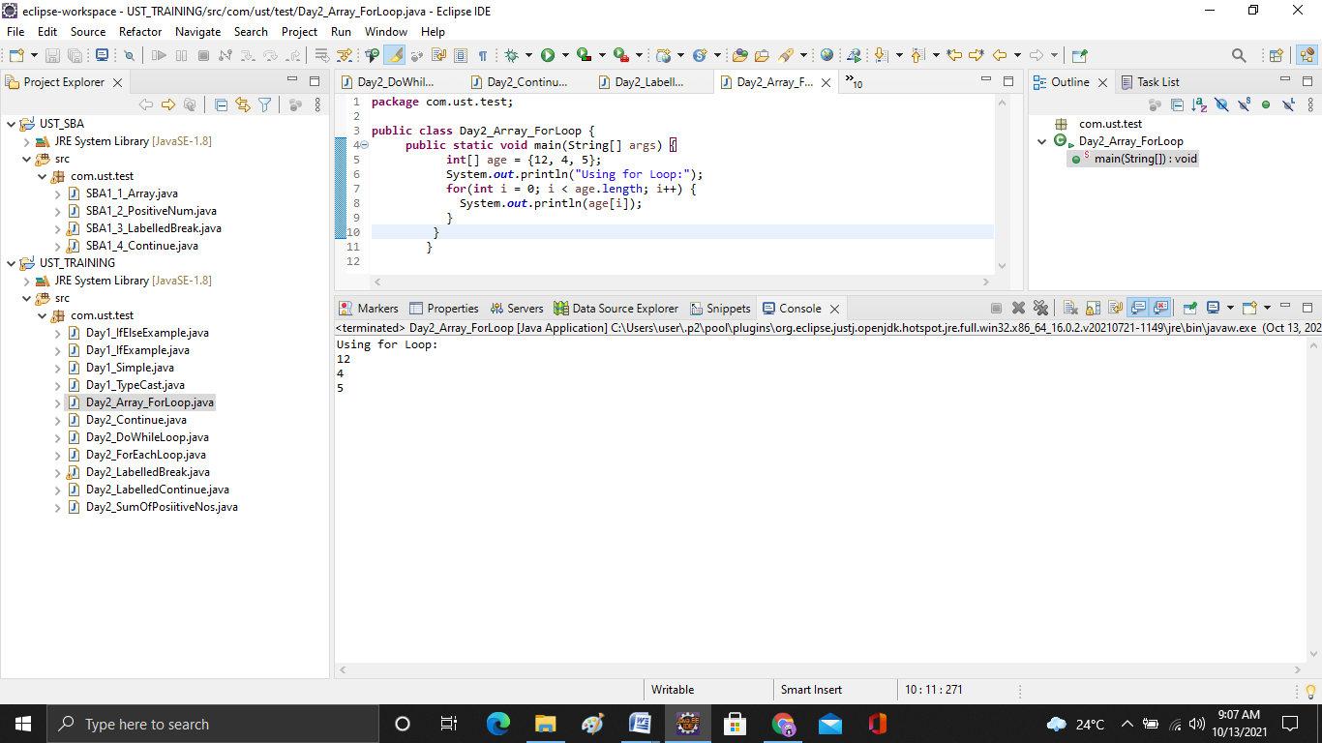

**PROGRAM :** Day2_Array_ForEachLoop.java

**package** com.ust.test;

**public** **class** Day2_Array_ForEachLoop {

**public** **static** **void** main(String[] args) {

**int**[] age = {12, 4, 5};

System.***out***.println("Using for-each Loop:");

**for**(**int** a : age) {

System.***out***.println(a);

}

}

}

**OUTPUT**

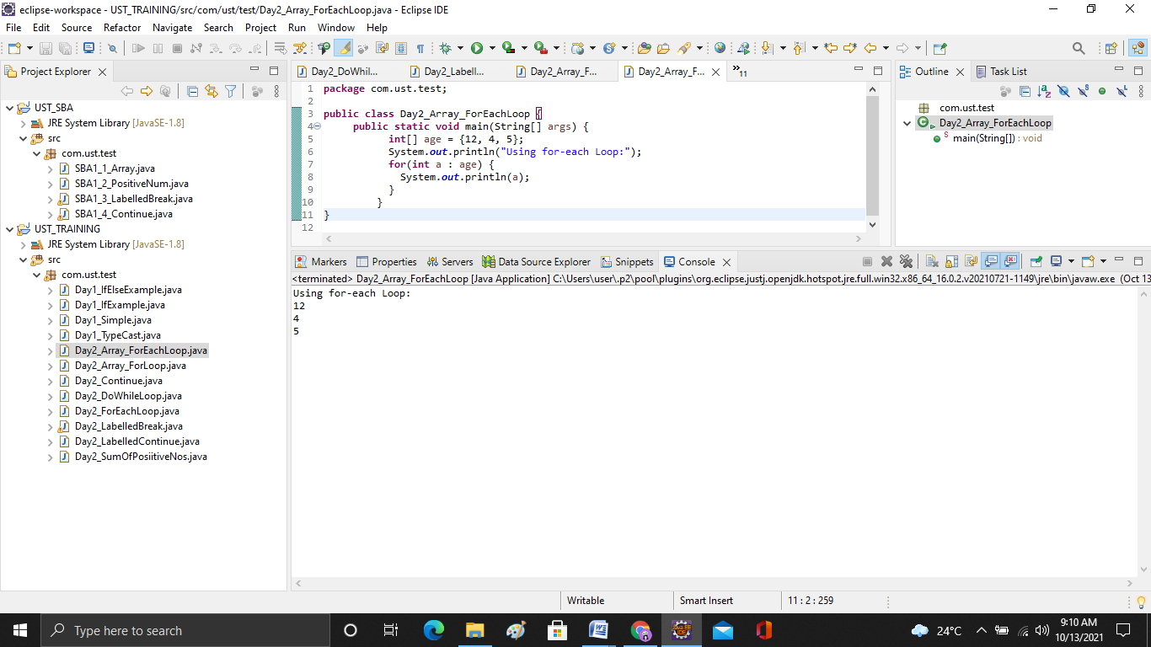

**PROGRAM :** Day2_Array_Average.java

**package** com.ust.test;

**public** **class** Day2_Array_Average {

**public** **static** **void** main(String[] args) {

**int**[] numbers = {2, -9, 0, 5, 12, -25, 22, 9, 8, 12};

**int** sum = 0;

Double average;

**for** (**int** number: numbers) {

sum += number;

}

**int** arrayLength = numbers.length;

average = ((**double**)sum / (**double**)arrayLength);

System.***out***.println("Sum = " + sum);

System.***out***.println("Average = " + average);

}

}

**OUTPUT**

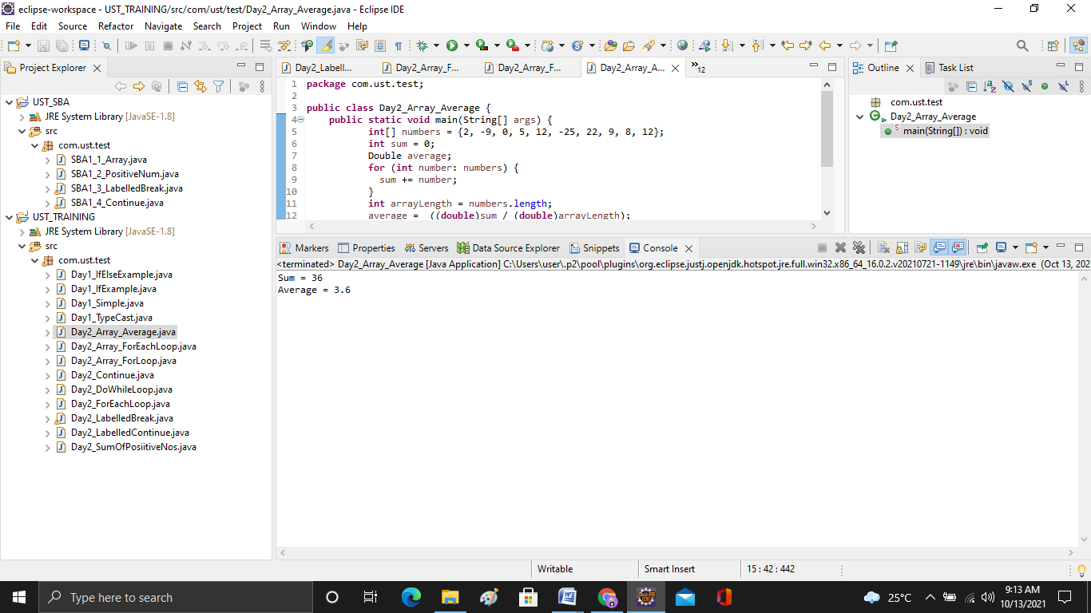

**PROGRAM :** Day2_PostDecrementOperator.java

**package** com.ust.test;

**public** **class** Day2_PostDecrementOperator {

**public** **static** **void** main(String args[])

{

**int** i = 5, j = 5, sum = 0;

System.***out***.println("Value of i is " + i + ", j is " + j +" and sum is " + sum);

sum = i + j--;

System.***out***.println("Value of i is " + i + ", j is " + j +" and sum is " + sum);

}

}

**OUTPUT**

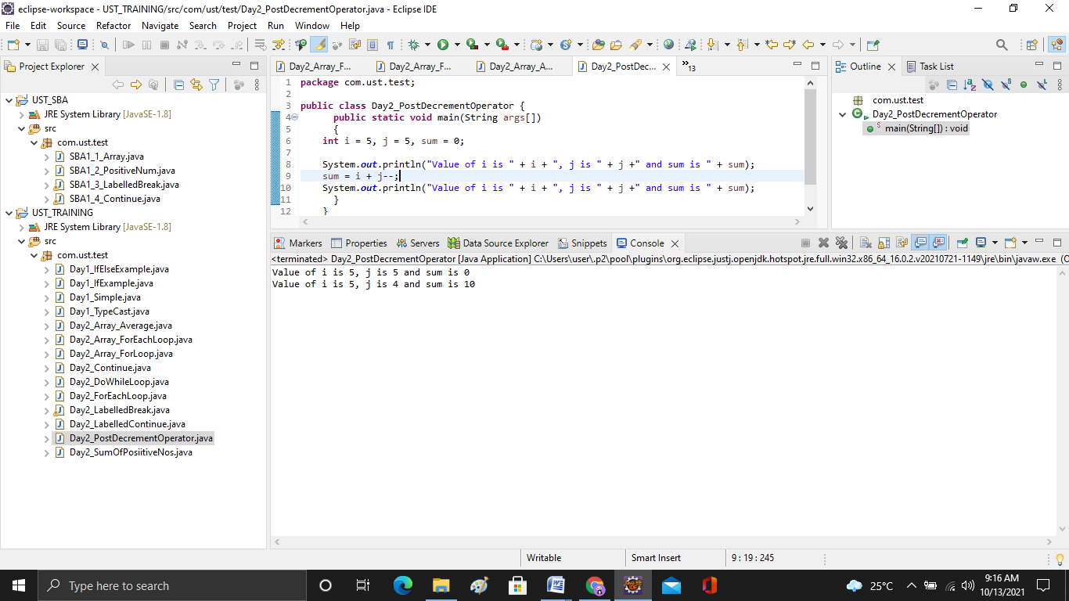

**PROGRAM :**

class Operator {

public static void main(String[] args) {

int a = 6, b = 6;

// a is displayed

// Then, a is increased to 7.

System.out.println(a++);

// b is increased to 6

// Then, b is displayed

System.out.println(++b);

}

}

**OUTPUT**

**PROGRAM :**

**OUTPUT**

**PROGRAM: .java**

**OUTPUT**

**PROGRAM: .java**

**OUTPUT**

**PROGRAM: .java**

**OUTPUT**

**PROGRAM: .java**

**OUTPUT**

**PROGRAM: .java**

**OUTPUT**

**PROGRAM: .java**

**OUTPUT**

**PROGRAM: .java**

**OUTPUT**

**PROGRAM: .java**

**OUTPUT**

**PROGRAM: .java**

**OUTPUT**

**PROGRAM: .java**

**OUTPUT**

**PROGRAM: .java**

**OUTPUT**

**PROGRAM: .java**

**OUTPUT**

**PROGRAM: .java**

**OUTPUT**

**PROGRAM: .java**

**OUTPUT**

**PROGRAM: .java**

**OUTPUT**

**PROGRAM: .java**

**OUTPUT**

**PROGRAM: .java**

**OUTPUT**

**PROGRAM: .java**

**OUTPUT**

**PROGRAM: .java**

**OUTPUT**

**PROGRAM: .java**

**OUTPUT**

**PROGRAM: .java**

**OUTPUT**

**PROGRAM: .java**

**OUTPUT**

**PROGRAM: .java**

**OUTPUT**

**PROGRAM: .java**

**OUTPUT**

**PROGRAM: .java**

**OUTPUT**

**PROGRAM: .java**

**OUTPUT**

**PROGRAM: .java**

**OUTPUT**

**PROGRAM: .java**

**OUTPUT**

**PROGRAM: .java**

**OUTPUT**

**PROGRAM: .java**

**OUTPUT**

**PROGRAM: .java**

**OUTPUT**

**PROGRAM: .java**

**OUTPUT**

**PROGRAM: .java**

**OUTPUT**

**PROGRAM: .java**

**OUTPUT**

**PROGRAM: .java**

**OUTPUT**

**PROGRAM: .java**

**OUTPUT**

**PROGRAM: .java**

**OUTPUT**

**PROGRAM: .java**

**OUTPUT**

**PROGRAM: .java**

**OUTPUT**

**PROGRAM: .java**

**OUTPUT**

**PROGRAM: .java**

**OUTPUT**

**PROGRAM: .java**

**OUTPUT**

**PROGRAM: .java**

**OUTPUT**

**PROGRAM: .java**

**OUTPUT**

**PROGRAM: .java**

**OUTPUT**

**PROGRAM: .java**

**OUTPUT**

**PROGRAM: .java**

**OUTPUT**

**PROGRAM: .java**

**OUTPUT**

**PROGRAM: .java**

**OUTPUT**

**PROGRAM: .java**

**OUTPUT**

**PROGRAM: .java**

**OUTPUT**

**PROGRAM: .java**

**OUTPUT**

**PROGRAM: .java**

**OUTPUT**

**PROGRAM: .java**

**OUTPUT**

**PROGRAM: .java**

**OUTPUT**

**PROGRAM: .java**

**OUTPUT**

**PROGRAM: .java**

**OUTPUT**

**PROGRAM: .java**

**OUTPUT**

**PROGRAM: .java**

**OUTPUT**

**PROGRAM: .java**

**OUTPUT**

**PROGRAM: .java**

**OUTPUT**

**PROGRAM: .java**

**OUTPUT**

**PROGRAM: .java**

**OUTPUT**

**PROGRAM: .java**

**OUTPUT**

**PROGRAM: .java**

**OUTPUT**

**PROGRAM: .java**

**OUTPUT**

**PROGRAM: .java**

**OUTPUT**

**PROGRAM: .java**

**OUTPUT**

**PROGRAM: .java**

**OUTPUT**

**PROGRAM: .java**

**OUTPUT**

**PROGRAM: .java**

**OUTPUT**

**PROGRAM: .java**

**OUTPUT**

**PROGRAM: .java**

**OUTPUT**

**PROGRAM: .java**

**OUTPUT**

**PROGRAM: .java**

**OUTPUT**

**PROGRAM: .java**

**OUTPUT**

**PROGRAM: .java**

**OUTPUT**

**PROGRAM: .java**

**OUTPUT**

**PROGRAM: .java**

**OUTPUT**

**PROGRAM: .java**

**OUTPUT**

**PROGRAM: .java**

**OUTPUT**

**PROGRAM: .java**

**OUTPUT**

**PROGRAM: .java**

**OUTPUT**

**PROGRAM: .java**

**OUTPUT**

**PROGRAM: .java**

**OUTPUT**

**PROGRAM: .java**

**OUTPUT**

**PROGRAM: .java**

**OUTPUT**

**PROGRAM: .java**

**OUTPUT**

**PROGRAM: .java**

**OUTPUT**

**PROGRAM: .java**

**OUTPUT**

**PROGRAM: .java**

**OUTPUT**

**PROGRAM: .java**

**OUTPUT**

**PROGRAM: .java**

**OUTPUT**

**PROGRAM: .java**

**OUTPUT**

**PROGRAM: .java**

**OUTPUT**

**PROGRAM: .java**

**OUTPUT**

**PROGRAM: .java**

**OUTPUT**

**PROGRAM: .java**

**OUTPUT**

**PROGRAM: .java**

**OUTPUT**

**PROGRAM: .java**

**OUTPUT**

**PROGRAM: .java**

**OUTPUT**

**PROGRAM: .java**

**OUTPUT**

**PROGRAM: .java**

**OUTPUT**

**PROGRAM: .java**

**OUTPUT**

**PROGRAM: .java**

**OUTPUT**

**PROGRAM: .java**

**OUTPUT**

**PROGRAM: .java**

**OUTPUT**

**PROGRAM: .java**

**OUTPUT**

**PROGRAM: .java**

**OUTPUT**

**PROGRAM: .java**

**OUTPUT**

**PROGRAM: .java**

**OUTPUT**

**PROGRAM: .java**

**OUTPUT**

**PROGRAM: .java**

**OUTPUT**

**PROGRAM: .java**

**OUTPUT**

**PROGRAM: .java**

**OUTPUT**

**PROGRAM: .java**

**OUTPUT**

**PROGRAM: .java**

**OUTPUT**

**PROGRAM: .java**

**OUTPUT**

**PROGRAM: .java**

**OUTPUT**

**PROGRAM: .java**

**OUTPUT**

**PROGRAM: .java**

**OUTPUT**

**PROGRAM: .java**

**OUTPUT**

**PROGRAM: .java**

**OUTPUT**

**PROGRAM: .java**

**OUTPUT**

**PROGRAM: .java**

**OUTPUT**

**PROGRAM: .java**

**OUTPUT**

**PROGRAM: .java**

**OUTPUT**

**PROGRAM: .java**

**OUTPUT**

**PROGRAM: .java**

**OUTPUT**

**PROGRAM: .java**

**OUTPUT**

**PROGRAM: .java**

**OUTPUT**

**PROGRAM: .java**

**OUTPUT**

**PROGRAM: .java**

**OUTPUT**

**PROGRAM: .java**

**OUTPUT**

**PROGRAM: .java**

**OUTPUT**

**PROGRAM: .java**

**OUTPUT**

**PROGRAM: .java**

**OUTPUT**

**PROGRAM: .java**

**OUTPUT**

**PROGRAM: .java**

**OUTPUT**

**PROGRAM: .java**

**OUTPUT**

**PROGRAM: .java**

**OUTPUT**

**PROGRAM: .java**

**OUTPUT**

**PROGRAM: .java**

**OUTPUT**

**PROGRAM: .java**

**OUTPUT**

**PROGRAM: .java**

**OUTPUT**

**PROGRAM: .java**

**OUTPUT**

**PROGRAM: .java**

**OUTPUT**

**PROGRAM: .java**

**OUTPUT**

**PROGRAM: .java**

**OUTPUT**

**PROGRAM: .java**

**OUTPUT**

**PROGRAM: .java**

**OUTPUT**

**PROGRAM: .java**

**OUTPUT**

**PROGRAM: .java**

**OUTPUT**

**PROGRAM: .java**

**OUTPUT**

**PROGRAM: .java**

**OUTPUT**

**PROGRAM: .java**

**OUTPUT**

**PROGRAM: .java**

**OUTPUT**

**PROGRAM: .java**

**OUTPUT**

**PROGRAM: .java**

**OUTPUT**

**PROGRAM: .java**

**OUTPUT**

**PROGRAM: .java**

**OUTPUT**

**PROGRAM: .java**

**OUTPUT**

**PROGRAM: .java**

**OUTPUT**

**PROGRAM: .java**

**OUTPUT**

**PROGRAM: .java**

**OUTPUT**

**PROGRAM: .java**

**OUTPUT**

**PROGRAM: .java**

**OUTPUT**

**PROGRAM: .java**

**OUTPUT**

**PROGRAM: .java**

**OUTPUT**

**PROGRAM: .java**

**OUTPUT**

**PROGRAM: .java**

**OUTPUT**

**PROGRAM: .java**

**OUTPUT**

**PROGRAM: .java**

**OUTPUT**

**PROGRAM: .java**

**OUTPUT**

**PROGRAM: .java**

**OUTPUT**

**PROGRAM: .java**

**OUTPUT**

**PROGRAM: .java**

**OUTPUT**

**PROGRAM: .java**

**OUTPUT**

**PROGRAM: .java**

**OUTPUT**

**PROGRAM: .java**

**OUTPUT**

**PROGRAM: .java**

**OUTPUT**

**PROGRAM: .java**

**OUTPUT**

**PROGRAM: .java**

**OUTPUT**

**PROGRAM: .java**

**OUTPUT**

**PROGRAM: .java**

**OUTPUT**

**PROGRAM: .java**

**OUTPUT**

**PROGRAM: .java**

**OUTPUT**

**PROGRAM: .java**

**OUTPUT**

**PROGRAM: .java**

**OUTPUT**

**PROGRAM: .java**

**OUTPUT**

**PROGRAM: .java**

**OUTPUT**

**PROGRAM: .java**

**OUTPUT**

**PROGRAM: .java**

**OUTPUT**

**PROGRAM: .java**

**OUTPUT**

**PROGRAM: .java**

**OUTPUT**

**PROGRAM: .java**

**OUTPUT**

**PROGRAM: .java**

**OUTPUT**

**PROGRAM: .java**

**OUTPUT**

**PROGRAM: .java**

**OUTPUT**

**PROGRAM: .java**

**OUTPUT**

**PROGRAM: .java**

**OUTPUT**

**PROGRAM: .java**

**OUTPUT**

**PROGRAM: .java**

**OUTPUT**

**PROGRAM: .java**

**OUTPUT**

**PROGRAM: .java**

**OUTPUT**

**PROGRAM: .java**

**OUTPUT**

**PROGRAM: .java**

**OUTPUT**

**PROGRAM: .java**

**OUTPUT**

**PROGRAM: .java**

**OUTPUT**

**PROGRAM: .java**

**OUTPUT**

**PROGRAM: .java**

**OUTPUT**

**PROGRAM: .java**

**OUTPUT**

**PROGRAM: .java**

**OUTPUT**

**PROGRAM: .java**

**OUTPUT**

**PROGRAM: .java**

**OUTPUT**

**PROGRAM: .java**

**OUTPUT**

**PROGRAM: .java**

**OUTPUT**

**PROGRAM: .java**

**OUTPUT**

**PROGRAM: .java**

**OUTPUT**

**PROGRAM: .java**

**OUTPUT**

**PROGRAM: .java**

**OUTPUT**

**PROGRAM: .java**

**OUTPUT**

**PROGRAM: .java**

**OUTPUT**

**PROGRAM: .java**

**OUTPUT**

**PROGRAM: .java**

**OUTPUT**

**PROGRAM: .java**

**OUTPUT**

**PROGRAM: .java**

**OUTPUT**

**PROGRAM: .java**

**OUTPUT**

**PROGRAM: .java**

**OUTPUT**

**PROGRAM: .java**

**OUTPUT**

**PROGRAM: .java**

**OUTPUT**

**PROGRAM: .java**

**OUTPUT**

**PROGRAM: .java**

**OUTPUT**

**PROGRAM: .java**

**OUTPUT**

**PROGRAM: .java**

**OUTPUT**

**PROGRAM: .java**

**OUTPUT**

**PROGRAM: .java**

**OUTPUT**

**PROGRAM: .java**

**OUTPUT**

**PROGRAM: .java**

**OUTPUT**

**PROGRAM: .java**

**OUTPUT**

**PROGRAM: .java**

**OUTPUT**

**PROGRAM: .java**

**OUTPUT**

**PROGRAM: .java**

**OUTPUT**

**PROGRAM: .java**

**OUTPUT**

**PROGRAM: .java**

**OUTPUT**

**PROGRAM: .java**

**OUTPUT**

**PROGRAM: .java**

**OUTPUT**

**PROGRAM: .java**

**OUTPUT**

**PROGRAM: .java**

**OUTPUT**

**PROGRAM: .java**

**OUTPUT**

**PROGRAM: .java**

**OUTPUT**

**PROGRAM: .java**

**OUTPUT**

**PROGRAM: .java**

**OUTPUT**

**PROGRAM: .java**

**OUTPUT**

**PROGRAM: .java**

**OUTPUT**

**PROGRAM: .java**

**OUTPUT**

**PROGRAM: .java**

**OUTPUT**

**PROGRAM: .java**

**OUTPUT**

**PROGRAM: .java**

**OUTPUT**

**PROGRAM: .java**

**OUTPUT**

**PROGRAM: .java**

**OUTPUT**

**PROGRAM: .java**

**OUTPUT**

**PROGRAM: .java**

**OUTPUT**

**PROGRAM: .java**

**OUTPUT**

**PROGRAM: .java**

**OUTPUT**

**PROGRAM: .java**

**OUTPUT**

**PROGRAM: .java**

**OUTPUT**

**PROGRAM: .java**

**OUTPUT**

**PROGRAM: .java**

**OUTPUT**

**PROGRAM: .java**

**OUTPUT**

**PROGRAM: .java**

**OUTPUT**

**PROGRAM: .java**

**OUTPUT**

**PROGRAM: .java**

**OUTPUT**

**PROGRAM: .java**

**OUTPUT**